SIMATS ENGINEERING
ASSESSMENT TOOL 1 -Constraint Based Problem Solving

COURSE NAME: R PROGRAMMING COURSE CODE: ITA0402

COURSE OUTCOME COVERED

CO1: Apply R programming fundamentals including data structures, vectors, matrices, arrays, and class types to perform mathematical operations and manage data effectively. Identify and implement appropriate control structures to solve a particular programming problem
(Bloom Level -BL3- BL4)

Assessment Tool Weightage: 20%

QUESTIONS: 5 Questions Total Marks: 100

Code of Conduct:

I RAKSHITH R.R (192324156) ( (Name / Reg No) certify that this submission is my original work and that I have adhered to the guidelines specified for this assessment.
I understand that any violation of academic integrity rules will result in disciplinary action.

Signature of the student:


1. Student Performance Analysis
A college stores the marks of 10 students in Mathematics, Physics, and Chemistry. Write an R program to:
- Store the marks in a matrix.
- Calculate subject-wise averages.
- Find the highest and lowest scorer in each subject.
- Display students scoring above the overall average.

2. Employee Salary Processing
An organization maintains employee details including Employee ID, Name, Basic Pay, and Allowance.
Write an R program using appropriate data structures to:
- Calculate Gross Salary.
- Identify employees earning above ₹50,000.
- Display the employee with the highest salary.
- Generate a summary report.

3. Weather Data Analysis Using Arrays
Daily temperature data for three cities is collected for 7 days.
Write an R program to:
- Store the data in a 3-dimensional array.
- Find the average temperature for each city.
- Identify the hottest day.
- Compare city-wise temperature variations.

4. Product Inventory Management
A store maintains product information such as Product ID, Product Name, Quantity, and Price.
Using lists and vectors in R:
- Calculate inventory value for each product.
- Find products with stock below a threshold value.
- Generate a stock summary report.

5. Bank Account Processing Using Functions
Develop an R program with user-defined functions to:
- Deposit money.
- Withdraw money.
- Check account balance.
- Display transaction history.
Use suitable variables and functions.

6. Hospital Patient Data Analysis
A hospital stores patient details including Age, Gender, and Treatment Cost.
Write an R program to:
- Store the information in a data frame.
- Calculate average treatment cost.
- Find patients above 60 years of age.
- Generate statistical summaries.

7. Logical Vector-Based Voting Eligibility System
Create a dataset containing Name and Age of citizens.
Using logical vectors:
- Determine voting eligibility (Age ≥ 18).
- Count eligible and ineligible voters.
- Display the percentage of eligible voters.

8. Matrix-Based Sales Analysis
A company records monthly sales for four products across three regions.
Write an R program to:
- Store the sales data in a matrix.
- Calculate region-wise and product-wise sales totals.
- Identify the best-performing product.
- Display the region with maximum sales.

9. Library Management Using S3 Class
Design an S3 class named Book with attributes:
- Book ID
- Title
- Author
- Number of Copies
Write methods to:
- Display book details.
- Update available copies.
- Search for a specific book.

10. University Information System Using S4 Class and Reference Class
Create an S4 class named Student with slots:
- Roll Number
- Name
- CGPA
Create a Reference Class to:
- Add student records.
- Modify CGPA.
- Display student details.
- Find students with CGPA greater than 8.0.

RUBRICS FOR CALCULATION:

Criteria | Weightage | Level 4 – Exemplary | Level 3 – Proficient | Level 2 – Developing | Level 1 – Beginning
Understanding of Problem Context | 20 | Clearly understands the problem and accurately identifies all requirements | Good understanding with minor gaps | Basic understanding; some requirements unclear | Poor understanding or misinterpretation of the problem
Application of Concepts | 30 | Accurately applies appropriate concepts to solve complex problems | Applies relevant concepts correctly with minor errors | Applies basic concepts with limited accuracy | Fails to apply appropriate concepts
Problem-Solving Approach | 20 | Logical, well-structured, and efficient approach | Mostly logical approach with minor gaps | Basic approach with some inconsistencies | Illogical or unclear approach
Accuracy of Solution | 20 | Completely correct solution with proper justification | Mostly correct with minor errors | Partially correct solution | Incorrect or incomplete solution
Clarity | 10 | Clear, well-organized, and properly explained solution | Understandable with minor clarity issues | Limited clarity and explanation | Poorly presented and difficult to understand

1. Student Performance Analysis
A college stores the marks of 10 students in Mathematics, Physics, and Chemistry. Write an R program to:
- Store the marks in a matrix.
- Calculate subject-wise averages.
- Find the highest and lowest scorer in each subject.
- Display students scoring above the overall average.
Approach:
A 10 x 3 matrix (students x subjects) is created with named rows and columns. colMeans() gives subject-wise averages; a for loop with which.max()/which.min() finds the highest and lowest scorer in each subject; rowMeans() is compared with the overall mean() to list students scoring above the overall average.
Code:
# Q1: Student Performance Analysis (Matrix)
marks <- matrix(c(78,85,72, 92,88,95, 65,70,68, 81,79,84, 55,62,58,
90,94,89, 73,68,77, 86,91,82, 60,58,64, 95,97,93),
nrow = 10, ncol = 3, byrow = TRUE,
dimnames = list(paste0("Student", 1:10),
c("Maths", "Physics", "Chemistry")))
cat("Marks Matrix:\n"); print(marks)

cat("\nSubject-wise Averages:\n"); print(colMeans(marks))

cat("\nHighest and Lowest Scorer in Each Subject:\n")
for (sub in colnames(marks)) {
hi <- rownames(marks)[which.max(marks[, sub])]
lo <- rownames(marks)[which.min(marks[, sub])]
cat(sub, "-> Highest:", hi, "(", max(marks[, sub]), ")",
"| Lowest:", lo, "(", min(marks[, sub]), ")\n")
}

overall_avg <- mean(marks)
cat("\nOverall Average:", round(overall_avg, 2), "\n")
student_avg <- rowMeans(marks)
cat("Students scoring above overall average:\n")
print(round(student_avg[student_avg > overall_avg], 2))
Output:
Marks Matrix:
Maths Physics Chemistry
Student1 78 85 72
Student2 92 88 95
Student3 65 70 68
Student4 81 79 84
Student5 55 62 58
Student6 90 94 89
Student7 73 68 77
Student8 86 91 82
Student9 60 58 64
Student10 95 97 93

Subject-wise Averages:
Maths Physics Chemistry
77.5 79.2 78.2

Highest and Lowest Scorer in Each Subject:
Maths -> Highest: Student10 ( 95 ) | Lowest: Student5 ( 55 )
Physics -> Highest: Student10 ( 97 ) | Lowest: Student9 ( 58 )
Chemistry -> Highest: Student2 ( 95 ) | Lowest: Student5 ( 58 )

Overall Average: 78.3
Students scoring above overall average:
Student1 Student2 Student4 Student6 Student8 Student10
78.33 91.67 81.33 91.00 86.33 95.00
Output Screenshot:
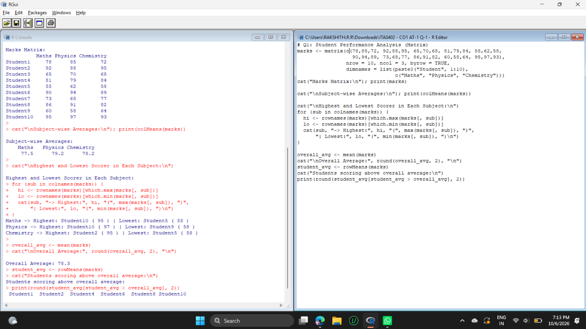

2. Employee Salary Processing
An organization maintains employee details including Employee ID, Name, Basic Pay, and Allowance.
Write an R program using appropriate data structures to:
- Calculate Gross Salary.
- Identify employees earning above ₹50,000.
- Display the employee with the highest salary.
- Generate a summary report.
Approach:
Employee details are stored in a data frame (suitable for mixed data types). Gross Salary = Basic Pay + Allowance is added as a new column. Logical indexing filters employees above Rs.50,000, which.max() finds the top earner, and cat() with sum/mean/max/min produces the summary report.
Code:
# Q2: Employee Salary Processing (Data Frame)
emp <- data.frame(
EmpID = 101:108,
Name = c("Arun","Priya","Kumar","Divya","Rahul","Sneha","Vikram","Meena"),
BasicPay = c(30000, 45000, 28000, 52000, 38000, 60000, 25000, 41000),
Allowance = c(8000, 12000, 6000, 15000, 9000, 18000, 5000, 10000)
)
emp$GrossSalary <- emp$BasicPay + emp$Allowance
cat("Employee Data with Gross Salary:\n"); print(emp)

cat("\nEmployees earning above Rs.50,000:\n")
print(emp[emp$GrossSalary > 50000, c("EmpID","Name","GrossSalary")])

cat("\nEmployee with Highest Salary:\n")
print(emp[which.max(emp$GrossSalary), c("EmpID","Name","GrossSalary")])

cat("\n----- SUMMARY REPORT -----\n")
cat("Total Employees :", nrow(emp), "\n")
cat("Total Salary Payout :", sum(emp$GrossSalary), "\n")
cat("Average Gross Salary :", mean(emp$GrossSalary), "\n")
cat("Highest Gross Salary :", max(emp$GrossSalary), "\n")
cat("Lowest Gross Salary :", min(emp$GrossSalary), "\n")
cat("Employees above 50000:", sum(emp$GrossSalary > 50000), "\n")
Output:
Employee Data with Gross Salary:
EmpID Name BasicPay Allowance GrossSalary
1 101 Arun 30000 8000 38000
2 102 Priya 45000 12000 57000
3 103 Kumar 28000 6000 34000
4 104 Divya 52000 15000 67000
5 105 Rahul 38000 9000 47000
6 106 Sneha 60000 18000 78000
7 107 Vikram 25000 5000 30000
8 108 Meena 41000 10000 51000

Employees earning above Rs.50,000:
EmpID Name GrossSalary
2 102 Priya 57000
4 104 Divya 67000
6 106 Sneha 78000
8 108 Meena 51000

Employee with Highest Salary:
EmpID Name GrossSalary
6 106 Sneha 78000

----- SUMMARY REPORT -----
Total Employees : 8
Total Salary Payout : 402000
Average Gross Salary : 50250
Highest Gross Salary : 78000
Lowest Gross Salary : 30000
Employees above 50000: 4
Output Screenshot:
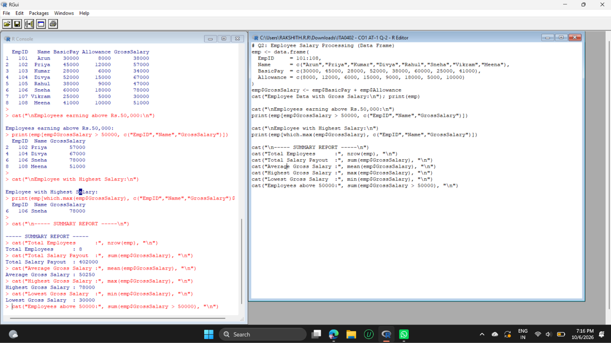

6. Hospital Patient Data Analysis
A hospital stores patient details including Age, Gender, and Treatment Cost.
Write an R program to:
- Store the information in a data frame.
- Calculate average treatment cost.
- Find patients above 60 years of age.
- Generate statistical summaries.
Approach:
Patient records are stored in a data frame. mean() gives the average treatment cost, logical indexing (Age > 60) selects senior patients, summary() generates the statistical summary, and tapply()/sd() give the gender-wise average cost and standard deviation.
Code:
# Q6: Hospital Patient Data Analysis (Data Frame)
patients <- data.frame(
PatientID = 1:10,
Age = c(25, 67, 45, 72, 34, 61, 58, 80, 29, 64),
Gender = c("M","F","F","M","F","M","F","M","F","M"),
TreatmentCost = c(12000, 45000, 20000, 60000, 15000, 38000,
25000, 75000, 11000, 42000)
)
cat("Patient Data:\n"); print(patients)

cat("\nAverage Treatment Cost:", mean(patients$TreatmentCost), "\n")

cat("\nPatients above 60 years:\n")
print(patients[patients$Age > 60, ])

cat("\nStatistical Summary:\n"); print(summary(patients))

cat("\nAverage Cost by Gender:\n")
print(tapply(patients$TreatmentCost, patients$Gender, mean))
cat("\nStd Deviation of Cost:", round(sd(patients$TreatmentCost), 2), "\n")
Output:
Patient Data:
PatientID Age Gender TreatmentCost
1 1 25 M 12000
2 2 67 F 45000
3 3 45 F 20000
4 4 72 M 60000
5 5 34 F 15000
6 6 61 M 38000
7 7 58 F 25000
8 8 80 M 75000
9 9 29 F 11000
10 10 64 M 42000

Average Treatment Cost: 34300

Patients above 60 years:
PatientID Age Gender TreatmentCost
2 2 67 F 45000
4 4 72 M 60000
6 6 61 M 38000
8 8 80 M 75000
10 10 64 M 42000

Statistical Summary:
PatientID Age Gender TreatmentCost
Min. : 1.00 Min. :25.00 Length :10 Min. :11000
1st Qu.: 3.25 1st Qu.:36.75 N.unique : 2 1st Qu.:16250
Median : 5.50 Median :59.50 N.blank : 0 Median :31500
Mean : 5.50 Mean :53.50 Min.nchar: 1 Mean :34300
3rd Qu.: 7.75 3rd Qu.:66.25 Max.nchar: 1 3rd Qu.:44250
Max. :10.00 Max. :80.00 Max. :75000

Average Cost by Gender:
F M
23200 45400

Std Deviation of Cost: 21623.29
Output Screenshot:
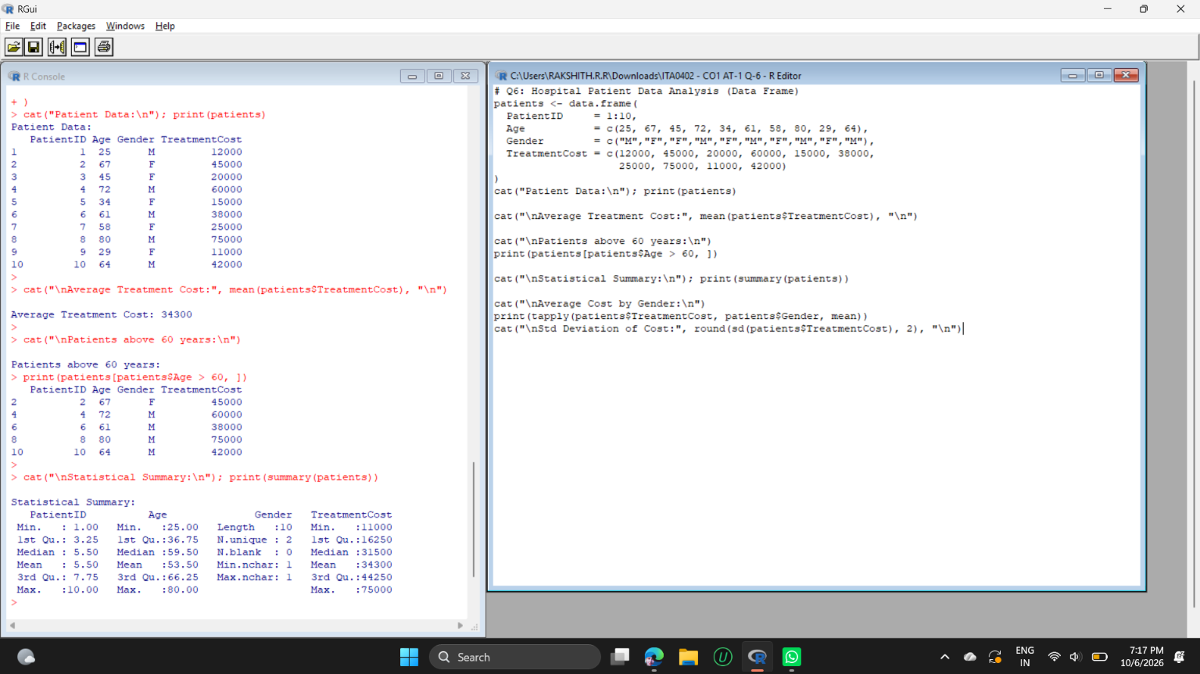

7. Logical Vector-Based Voting Eligibility System
Create a dataset containing Name and Age of citizens.
Using logical vectors:
- Determine voting eligibility (Age ≥ 18).
- Count eligible and ineligible voters.
- Display the percentage of eligible voters.
Approach:
Name and Age are stored as vectors/data frame. The logical vector Age >= 18 marks eligibility; since TRUE counts as 1, sum(eligible) counts eligible voters and sum(!eligible) counts ineligible ones. The percentage is (eligible / total) x 100.
Code:
# Q7: Voting Eligibility System (Logical Vectors)
name <- c("Arun","Priya","Kumar","Divya","Rahul","Sneha","Vikram","Meena","Ravi","Anita")
age <- c(25, 17, 18, 16, 45, 30, 15, 22, 17, 60)
citizens <- data.frame(Name = name, Age = age)

eligible <- citizens$Age >= 18
citizens$Eligible <- eligible
cat("Voting Eligibility Table:\n"); print(citizens)

cat("\nEligible Voters :", sum(eligible), "\n")
cat("Ineligible Voters:", sum(!eligible), "\n")
pct <- (sum(eligible) / length(eligible)) * 100
cat("Percentage of Eligible Voters:", pct, "%\n")

cat("\nEligible Names:", citizens$Name[eligible], "\n")
Output:
Voting Eligibility Table:
Name Age Eligible
1 Arun 25 TRUE
2 Priya 17 FALSE
3 Kumar 18 TRUE
4 Divya 16 FALSE
5 Rahul 45 TRUE
6 Sneha 30 TRUE
7 Vikram 15 FALSE
8 Meena 22 TRUE
9 Ravi 17 FALSE
10 Anita 60 TRUE

Eligible Voters : 6
Ineligible Voters: 4
Percentage of Eligible Voters: 60 %

Eligible Names: Arun Kumar Rahul Sneha Meena Anita
Output Screenshot:
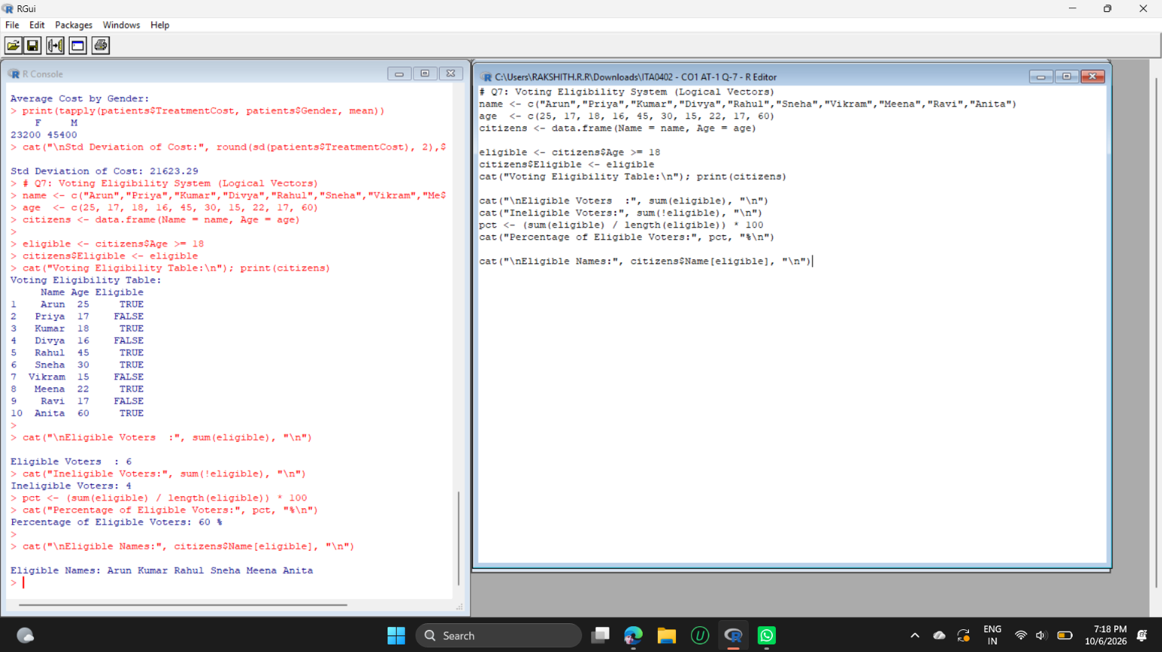

8. Matrix-Based Sales Analysis
A company records monthly sales for four products across three regions.
Write an R program to:
- Store the sales data in a matrix.
- Calculate region-wise and product-wise sales totals.
- Identify the best-performing product.
- Display the region with maximum sales.
Approach:
Monthly sales are stored in a 4 x 3 matrix (products x regions). rowSums() gives product-wise totals and colSums() gives region-wise totals; names(which.max()) identifies the best-performing product and the region with maximum sales.
Code:
# Q8: Matrix-Based Sales Analysis
sales <- matrix(c(25000, 30000, 28000,
40000, 35000, 45000,
15000, 20000, 18000,
32000, 28000, 36000),
nrow = 4, ncol = 3, byrow = TRUE,
dimnames = list(c("Product A","Product B","Product C","Product D"),
c("North","South","East")))
cat("Sales Matrix:\n"); print(sales)

product_total <- rowSums(sales)
region_total <- colSums(sales)
cat("\nProduct-wise Total Sales:\n"); print(product_total)
cat("\nRegion-wise Total Sales:\n"); print(region_total)

best_product <- names(which.max(product_total))
cat("\nBest-Performing Product:", best_product,
"with sales of", max(product_total), "\n")

best_region <- names(which.max(region_total))
cat("Region with Maximum Sales:", best_region,
"with sales of", max(region_total), "\n")
Output:
Sales Matrix:
North South East
Product A 25000 30000 28000
Product B 40000 35000 45000
Product C 15000 20000 18000
Product D 32000 28000 36000

Product-wise Total Sales:
Product A Product B Product C Product D
83000 120000 53000 96000

Region-wise Total Sales:
North South East
112000 113000 127000

Best-Performing Product: Product B with sales of 120000
Region with Maximum Sales: East with sales of 127000
Output Screenshot:


